UNION BANK OF INDIA

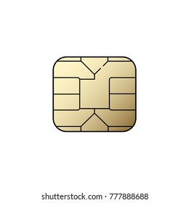 

5354 5657 6869 8990 03/05/2024 Gaurav Pandey